**Project Description and Approach**

1.**Manager Home Screen** – Altered table employee and skills, added **employee_id** as **primary key** to connect skill, skilllock and employee table to generate query to get data,

ALTER TABLE `wfm`.`employees`

ADD PRIMARY KEY (`employee_id`);

ALTER TABLE `wfm`.`skillmap`

RENAME TO `wfm`.`skillmaps` ;

**API** – <http://localhost:8000/employees/manager/faizal>

{Added Authentication token in header} – GET request

**API Response Screenshot -**

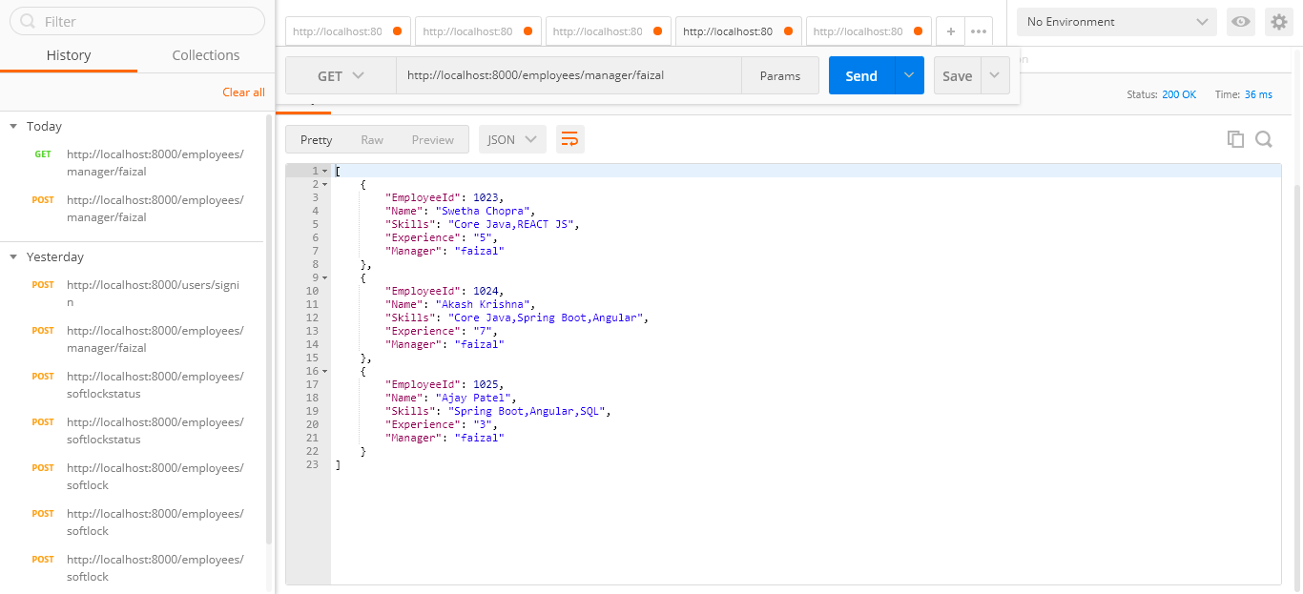

**Manger Home Screen Kendo Grid UI** – showing current logged In user data with pagination

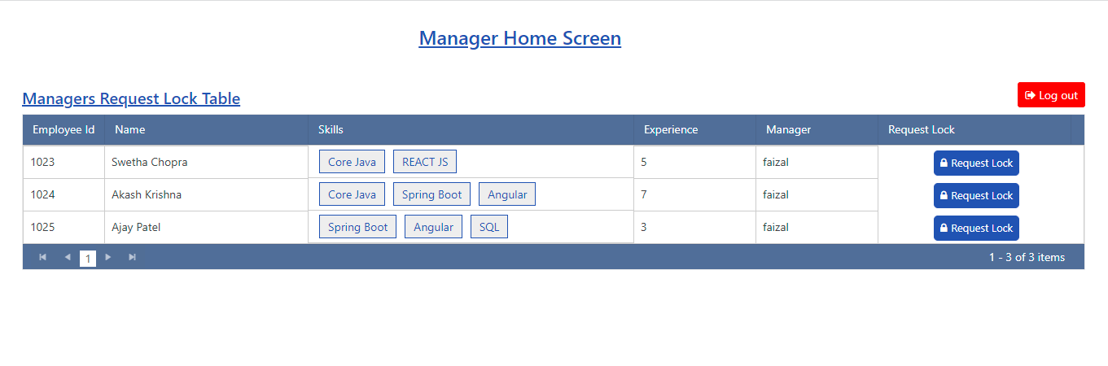

2. **Manager Screen Request Lock Popup -** Clicking on request detail raising request for current user to lock resource

**Altered softlock table-**

ALTER TABLE `wfm`.`softlock`

RENAME TO `wfm`.`softlocks` ;

**API** - <https://localhost:8000/employees/softlock> - Post request

**Post Body**-

{

"employee_id":1023,

"username":"faizal",

"requestmessage":"I need resource"

}

**API Response Screenshot –**

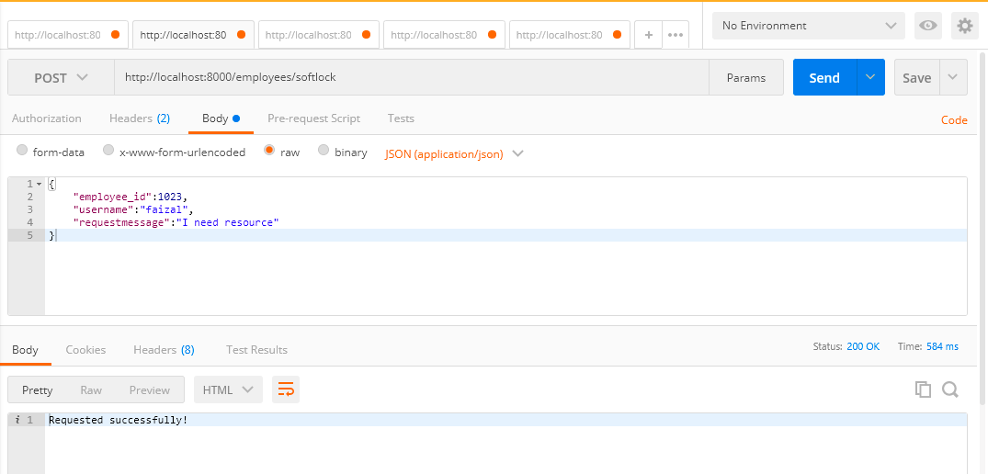

**Manager Lock Request Popup UI –** with validation to have atleast 10 char

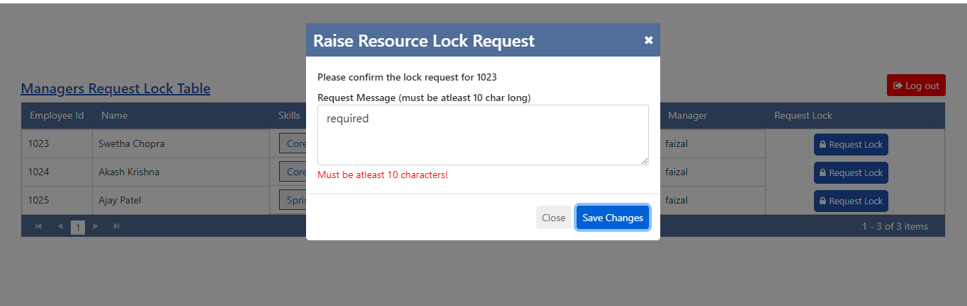

**Manager Home Screen kendo Grid after Raising request-**

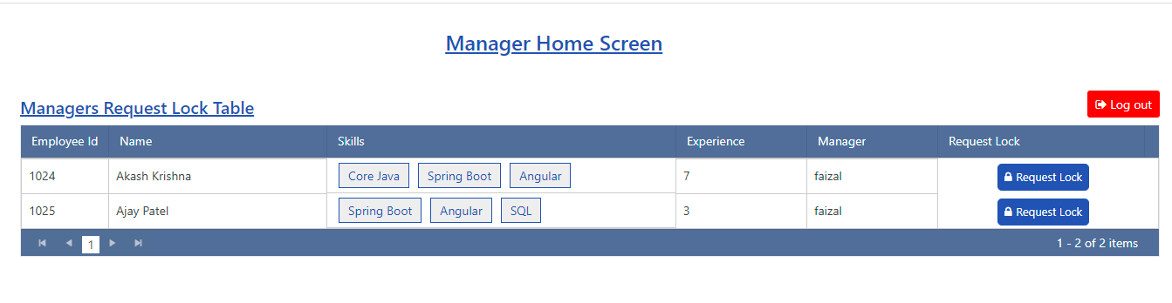

3.**WFM Screen** – Hold raised request to particular wfm manager

**API** -<http://localhost:8000/employees/wfm/lokesh> - GET request

**API Response Screenshot-**

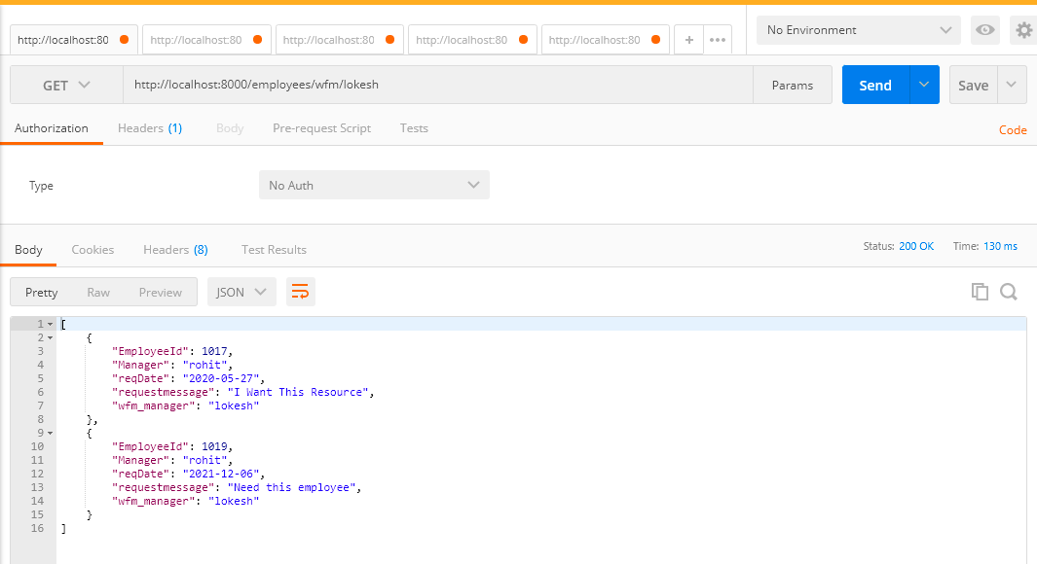

**WFM Home Screen React kendo grid UI-**

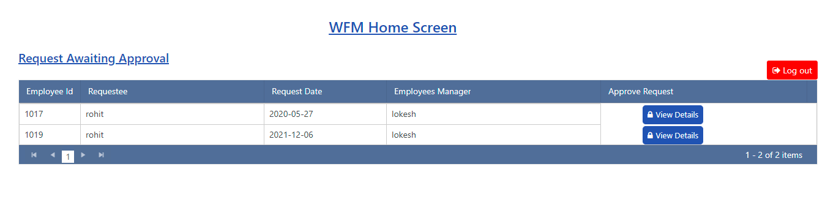

4.**Approve Lock Request Popup –**

**API -**<http://localhost:8000/employees/softlockstatus> POST request

**POST Body** –

{

"employee_id":1023,

"status":"accepted"

}

**API Response Screenshot-**

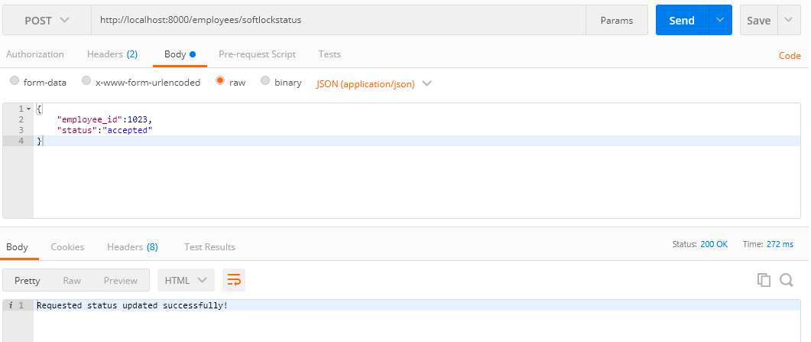

**WFM Request Lock Popup UI-**

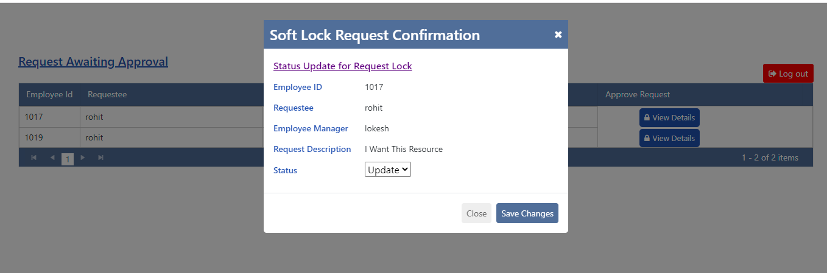

**WFM Home Screen after Approving/Rejecting request-**

